Pracovní list z angličtiny (7.)
Unit 4

2 Přečtěte si text, opravte chyby v následujících větách.
Visit to London
We spent our holiday in London last month and we had a fantastic time. My favourite thing about London is the River Thames. We crossed the river about six times and every time I thought the view was fantastic! From Westminster Bridge you can see all along the River Thames. You can see Big Ben and the London Eye. That’s fantastic, too. It’s the biggest wheel in the world and you have an even better view of London from it. From the river you can see all the different buildings. There are old and new buildings all together. I like to imagine London 200 years ago – with all the horses and dirty roads. Perhaps people weren’t always in a hurry like they are today. From the river you can see all the history of this old city – that’s why I like it. I love the river at night, too. There are boats and restaurants, and all the lights are on. It’s beautiful. And there are always lots of people walking about.
I love all the places in London but I love the London buses and the taxis, too! London taxis are big and black and there’s a lot of space in them. You can get six people in them! The taxi drivers know everything about London and they’re really friendly. It’s an enormous city with lots of roads and little streets. The taxi drivers have to take a special test when they want to be a taxi driver. It’s called The Knowledge. They have to learn how to get to every street in London without using a sat nav or a map. Our taxi drivers didn’t get lost once! I’d like to be a London taxi driver, but I think it’s a very difficult job!

Finn crossed the river every day.
Finn crossed the river six times._________
1 You can see Buckingham Palace from the river.
________________________________
2 Westminster Bridge crosses the River Avon.
________________________________
3 There are only old buildings in London.
________________________________
4 There aren’t any boats on the river.
________________________________
5 London taxis are small and yellow.
________________________________
6 London taxi drivers are very quiet.
________________________________
7 London taxi drivers use a special map called The Knowledge.
________________________________
 | _____ | 14

3 Complete the sentences with the or – for no article.
My parents saw the Statue of Liberty when they visited New York.
1 I thought ________ Natural History Museum was fantastic.
2 We didn’t have time to visit ________ Edinburgh Castle last year.
3 ________ Fitzwilliam Museum is in Cambridge.
4 Would you like to see ________ We Will Rock You in London?
5 I bought this T-shirt in ________ Oxford Street.
6 I’d love to visit ________ Louvre in Paris.
7 Jane took lots of photos of ________ Big Ben.
 | _____ | 7
4 Doplňe do textu the, a or an.
I live in Exeter. It’s a town in (1) ________ south-west of England. I live in Topsham, but I go to school in St Leonards. It’s on (2) ________ other side of town. There’s a lot to do in Exeter. There are lots of shops and cafés, and there’s
(3) ________ old museum and (4) ________ famous cathedral. There are lots of cinemas, too. I often go to (5) ________ cinema with my friends at the weekend. (6) ________ River Exe runs through Exeter and I go canoeing with my brother Freddie. (7) ________ canoe club is on the river and it’s brilliant.
 | _____ | 7
5 Podtrhněte správné členy.
Go along here and take the road on the /
a / – right.
1 You’ll come to a / an / – supermarket. Go past the supermarket and it’s on your left.
2 Can you see a bridge? The Houses of Parliament are at the end of the / – / a bridge.
3 Excuse me. Where’s a / – / the Hyde Park?
4 Look at the theatre. The museum is next to the / a / – theatre.
5 There’s a / the / – / big park in my town, and I live next to the park.
6 The / A / – Big Ben is next to the river.
7 There isn’t the / – / an art gallery in our town.
 | _____ | 7

6 Doplňte slova.
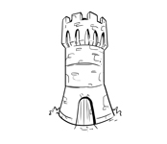 | 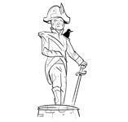
t o w e r | 1 s _ _ _ _ _
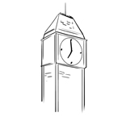 | 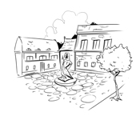
2 c _ _ _ _ | 3 s _ _ _ _ _
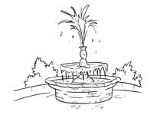 | 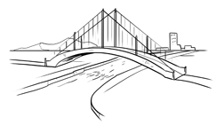
4 f _ _ _ _ _ _ _ | 5 b _ _ _ _ _
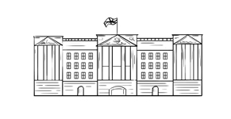
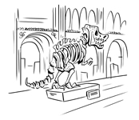
6 m _ _ _ _ _ | 7 p _ _ _ _ _

 | _____ | 7
7 Doplňte do vět zájmena v rámečku.
everyone somewhere something anything
someone nothing everywhere anywhere
I’ve got something to tell you.
1 I can't find my car keys ________! I think I have lost them!
2 ________ laughed when the clown fell over.
3 Is there ________ I can do to help?
4 After the flood my family was left with ________.
5 I called the police when I heard ________ scream.
6 We have looked ________ but we still can't find the car keys.
7 I've seen you ________ before! Where was it?
 | _____ | 7

Doplňte do vět chybějící předložky:
Alex Where do you live, Tom?
Tom I live in Gold Road. There’s a park opposite my house. We play football there after school.
Alex How do you get there from here?
Tom Go to the end of (1) ___________ street and (2) ___________ right. Walk (3) ___________ the library. There’s a supermarket on the (4) ___________ of Old Street. Go (5) ___________ on till you come to the river. The park is on the (6) ___________ side of the river, so go (7) ___________ the bridge. You’ll see the park on the right.
 | _____ | 7

