1 Read a text about superheroes. Correct the mistakes in the sentences.
People have always had heroes they can respect and admire. Sometimes these heroes are legendary characters from the past, like Robin Hood. Others are characters in books, like the great detective Sherlock Holmes. And then in 1930s, superheroes appeared in American comic books. One of the most famous was Superman, who appeared in the comic book series Action Comics in 1938. Since then Superman has become a film superhero as well, along with other much-loved superheroes like Batman and Spiderman.
So what characteristics do superheroes have? Firstly, they need to have extraordinary powers, which they use to do good and save the world. Superman, for example, can fly and he can see things that other people can’t. Secondly, they usually have a secret identity. For example, Clark Kent is a newspaper reporter, but when he is needed, he can change into Superman in a second. Of course, nobody in everyday life knows that Clark is also Superman and they never see him changing into a superhero with a red cape. Superheroes usually have a special costume and they often wear a mask as well. Thirdly, superheroes have a lot of enemies that they must fight, but they also have a weakness that their enemies can use to try to destroy them. Superman’s weakness is Kryptonite, the green material from his home planet of Krypton.
Not all superheroes are men. There are also many female superheroes, such as Wonder Woman, Catwoman and Batgirl, and some are nearly as old as the men. Wonder Woman first appeared in a comic book in 1941!
Now, we want to know about your favourite superhero or superheroine. Write a short article describing your favourite and tell us why you like him or her so much. Send it to us before 10th December. The writer of the best article will win two tickets for the premiere of the latest Batman film and they will have a chance to meet the star! So start writing!

The first superheroes were characters in films.
The first superheroes were characters in (American) comic books.
1 Comic book superheroes first appeared in the nineteenth century.
________________________________
2 Superman first appeared in a comic book in 1930.
________________________________
3 Batman can see better than normal people.
________________________________
4 In his normal life, Superman is a teacher.
________________________________
5 Superman’s enemies can use Krypton to hurt him.
________________________________
6 Wonder Woman appeared in a film for the first time in 1941.
________________________________
7 The prize for the best article is a Batman comic book.
________________________________

2 Podtrhni správné sloveso.
I don’t mind to get up / getting up early.

1 My brother hopes to play / playing in a rock band one day.
2 We really want to see / seeing that film.
3 I can’t imagine to be / being a doctor.
4 I often forget to read / reading my emails.
5 The knight promised to throw / throwing away the sword.
6 They didn’t finish to eat / eating until
two o’clock.
7 The band stopped to play / playing at midnight and everyone went home.

3 Doplňte do vět slovesný tvar s příponou –ing. Vybírejte z těchto sloves.
ring bark sing knock stand blow
climb lie
There were a lot of birds singing in the garden.
1 I remember seeing my grandmother ____________________ next to my bed.
2 There is a phone ____________________ downstairs.
3 There are a lot of people ____________________ on the beach.
4 I can feel the wind ____________________ in my hair.
5 There is someone ____________________ on the door.
6 I can hear a dog ____________________ at my cat!
7 I can see a burglar ____________________ over the gate.

4. Požádejte někoho o něco (použijte slovesa v závorce a daná slova)
give / me a lift into town (could)
Could you give me a lift into town?
1 turn / down the TV (mind)
________________________________
2 have / a cup of coffee (could)
________________________________
3 take / the dog for a walk (mind)
________________________________
4 do / the washing-up (could)
________________________________
5 help / me with my homework (mind)
________________________________
6 wash / the car for me (could)
________________________________
7 ask / Josh to phone me tomorrow (could)
___________________________________

6 Look at the pictures and write the words.
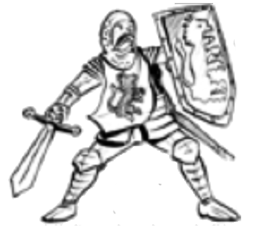 | 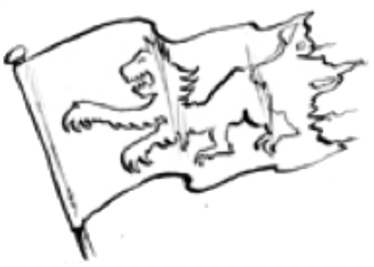
knight | 1 ___________
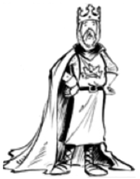 | 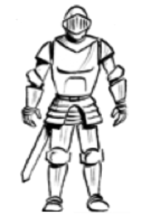
2 _____________ | 3 _____________
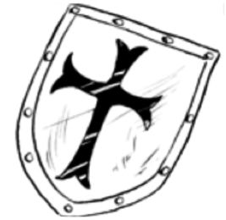 | 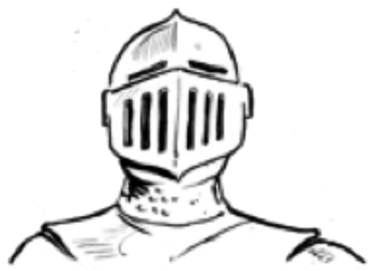
4 _____________ | 5 _______________

